Final Year Project Proposal
IOT BASED AIR QUALITY INDEX METER SYSTEM

Submitted by:
Huzaifa Shahbaz
21-CE-009
Aqsa Shah 21-CE-039
Supervisor Name:
MAAM SARA TEHSIN
LECTURER
Dated:
11th October 2024
Department of Computer Engineering,
HITEC University, Taxila

Contents
1.INTRODUCTION: 3
2.PROBLEM STATEMENT: 3
3.LITERATURE REVIEW/BACKGROUND: 4
4.PROPOSED DESGIN METHODOLGY /FRAMEWORK/ARCHITECTURE: 9
5. HARDWARE/SOFTWARE TOOLS: 12
6. PROPOSED WORK PLAN: 16
7.CONCLUSION: 19
8.REFERENCES: 20
9.COLLABORATORS: 22

1.INTRODUCTION:
In an era, the integration of IOT environmental monitoring systems, particularly Air quality Index(AQI) systems, is crucial for public health and environmental protection. With Urbanization and industrial activities increasing, real-time, accurate air quality data is essential. IOT based AQI systems enable continuous monitoring of air pollutants, providing timely insights and prompt responses to deteriorating air conditions.
IOT technology connects sensors to measure air pollutants like PM2.5, PM10, CO and NO₂. Data is transferred to a central server for analysis and accessibility. This real-time monitoring helps mitigate poor air quality impacts, shapes policies and raise awareness about maintaining a healthy environment. It also plays a crucial role in shaping policies and raising awareness.

2.PROBLEM STATEMENT:
The primary issue with this project is its lengthy detection range, which prevents it from accurately displaying the city's air quality reading on the sensors. Urbanization and industrialization have led to a decline in air quality, posing health risks and environmental issues. A project aims to develop an IOT-based AQI system to monitor air pollutants in real-time enabling timely interventions and informed decision-making. The project aims to identify key pollutants, analyze their impact on health and the environment and develop a robust system for continuous monitoring. The solution’s business scope includes urban planning, public health management and industrial compliance with primary end-users being environmental agencies, local governments, industries and the general public.

3.LITERATURE REVIEW/BACKGROUND:
IOT-based Air Quality Index(AQI) systems are gaining popularity due to concerns over air pollution and its impact on public health and the environment. These systems use low-cost, portable sensors to provide real-time on pollutants like PM2.5 ,PM10,CO,SO₂ AND NO₂.These sensors are connected via IOT to a central server, which processes and analyzes the data. This approach enhances spatial and temporal resolution of air quality data and facilitates proactive environmental management by providing real-time alerts and insights.
The integration of IOT in air quality data index(AQI) systems has the potential to revolutionize environmental monitoring by democratizing access to air quality data. Predictive data analytics powered by machine learning and cloud computing can improve system effectiveness, enabling early warning systems, informed decision making and public awareness. IOT-based AQI systems play a critical role in urban planning, public health management and industrial compliance, necessitating innovative solutions to combat air pollution.
Table 1:LITERATURE REVIEW OF AIR QUALITY INDEX
STUDY | AUTHORS | YEAR | KEY FINDINGS
Deployment of Low-Cost Sensors | Kumar et al. | 2019 | The study showcased the efficacy of low-cost, IoT-based sensors in monitoring scalable air quality.
Predictive Analytics in AQI Systems | Smith and Lee | 2020 | The integration of machine learning for predictive analytics has been highlighted as a method to improve early warning systems.
Real-Time Data for Public Health | Johnson et al. | 2021 | The use of real-time, IoT-based air quality data has significantly enhanced public health responses.
Enhancing Environmental Awareness | Chen and Patel | 2022 | The article highlighted the significant role of IoT in enhancing public engagement and raising awareness about air quality issues.
TABLE 2: Literature Review Comparison
Ref # | Published  year | Methodology | Results/ Findings | Parameters | Shortcomings/  Gaps
1. | 2020 | IoT and ML-based smart system for garbage monitoring | Real-time AQI monitoring and fire detection are being implemented for dump yards and garbage management. | Temperature, moisture, light intensity | The application is restricted to garbage management and does not cover general air quality monitoring.
2. | 2020 | IoT-based environmental quality control system | The method is effective in monitoring environmental pollutants. | Various air pollutants like CO2, SO2. | Large-scale deployments often face high costs and complexity.
3. | 2020 | IoT framework for urban air quality control | The text focuses on efficient air quality management with solutions that are nearly zero. | O3, NOx, CO2. | Limited scalability; issues with sensor calibration.
4. | 2020 | IoT-based indoor air quality control system | The system allows for real-time monitoring and control of indoor air quality. | CO2, VOCs | Indoor only; does not address outdoor air quality monitoring
Proposed System | 2021 | IoT-based system with Arduino and various sensors | The system monitors various pollutants like O3, SO2, CO, and particulate matter, providing data through a cloud-based interface. | O3, SO2, CO, particulate matter. | The deployment is limited and requires further testing for large-scale outdoor environments and long-term data accuracy.
1. | 2018 | IoT-based pollution monitoring | The system is continuously monitoring pollution levels through the use of multiple sensors. | CO, particulate matter, smoke. | Limited to predefined areas; lacks user interaction via mobile apps
2. | 2018 | Edge computing-based IoT architecture | The proposed solution aims to reduce cloud dependency by utilizing low-cost monitoring methods and local data processing. | CO, NOx, VOCs | The edge computing setup is highly complex and not easily scalable.
3. | 2018 | IoT-enabled air pollution monitoring and awareness. | Tracks pollutants and raises public awareness through displays and notifications | CO, NH3, particulate matter, smoke | Limited user customization; lacks predictive analytics for future air quality trends
Proposed System | 2023 | IoT-enabled air pollution meter with smartphone dashboard | The mobile app offers real-time data and alerts on air quality, including AQI calculations. | CO, NH3, particulate matter, smoke. | The system requires constant internet connection for real-time updates and is restricted to areas with smartphone accessibility.  The system requires constant internet connection for real-time updates and is restricted to areas with smartphone accessibility.
1. | 2020 | IoT-based smart environment monitoring | Detects pollutants like CO, smoke, gas; uses LCD for display. | CO, smoke, gas | Data retrieval limited to every 8 hours; no IoT integration.
2. | 2008 | Environment-al air pollution monitoring with IEEE 1451. | Monitors CO, NO2, SO2, O3 using semiconductor sensors | CO, NO2, SO2, O3 | The process necessitates calibration for various gases prior to each measurement
3. | 2018 | Centralized air pollution detection and monitoring | Uses microcontroller and WiFi module; supports various gas sensing methods | Multiple pollutants (method dependent) | Lacks specific IoT feature integration; manual data evaluation.
Proposed System | 2022 | Real-time indoor/outdoor monitoring with IoT | Uses ESP32, MQ135, DHT22; displays data via BLYNK app | CO2, temperature, humidity | Limited range due to WiFi module; performance dependent on stable network connection.

TABLE 3: Comparison of Proposed system with existing systems
Functionality | Proposed System | Existing System
 | Name | System name 1 | System name 2 | System name 3
Real-time monitoring | Yes | Yes | No | Yes
Data Accuracy | High | Medium | Low | Medium
Ease of use | Yes | No | Yes | No
Security | Yes | No | Yes | No
Alerts and Notification | Multiple Sensors Supported | Single Sensor | Single Sensor | Multiple Sensors Supported
Historical Data Analysis | Yes | No | No | Yes
Cost Efficiency | Moderate | High | Medium | Low
Scalability | High | Low | Medium | High
Maintenance Requirements | Low | High | Medium | Low

4.PROPOSED DESGIN METHODOLGY /FRAMEWORK/ARCHITECTURE:
ABSTRACT DESGIN:
The IOT-based Air Quality Index Meter uses advanced sensors to monitor air quality in real-time. It measures parameters like PM,CO₂ and NO₂ and transmits data via a wireless network to a cloud-based network. The data is analyzed and presented in a user-friendly format, aiming to create an accurate, reliable and user-centric air quality monitoring solution with real-time data visualization and historical analysis.
COMPONENT-LEVEL DESIGN:
The project involves designing sensor modules, microcontrollers and communication interfaces. Sensors will be chosen based on accuracy, range and reliability. The microcontroller unit will handle data acquisition, processing and transmission. Communication interfaces will facilitate seamless data transfer between sensor nodes and the cloud platform. Power management strategies will be incorporated for long-term operation.
SYSTEM REQUIRMENT SPECIFICATIONS(SRS):
The SRS document will outline the functional and non-functional requirements of an air quality index meter, covering accurate pollutant measurement, real-time data transmission and user alerts. It will also cover performances metrics. The SRS will guide development and testing to ensure the system meets all standards and user expectations.
EQUATIONS:
$AQI=[\frac{(PMobs-PMmin)*(AQImax-AQImin)}{(PMmax-PMmin)} ]+AQImin$->4.1
$\text{AQI=(}\frac{\text{Ci-Clow}}{Chigh-Clow})*\left(Ihigh-Ilow\right)+Ilow$->4.2
FIGURE:
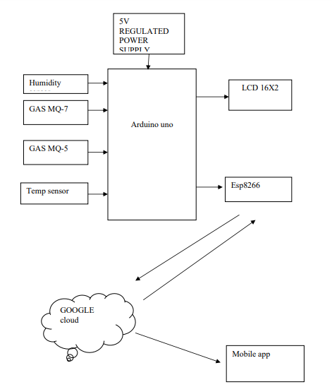
FIGURE 1:BLOCK DIAGRAM OF IOT BASED AQI METER
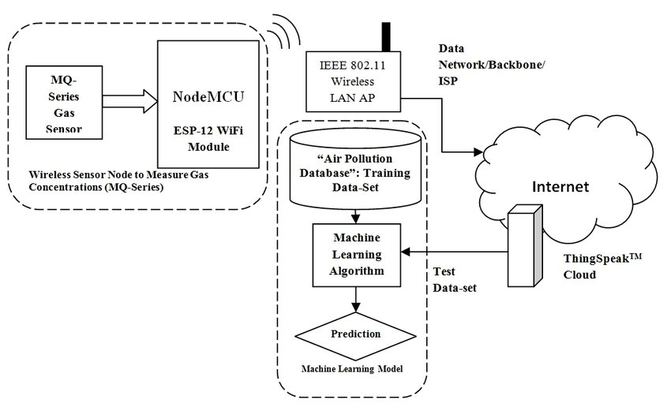
FIGURE 2:PROJECT DIAGRM OF IOT BASED AQI METER

5. HARDWARE/SOFTWARE TOOLS:
HARDWARE TOOLS:
1:ESP32/ESP8266
2:ARDUINO
3:MQ SERIES GAS SENSOR(MQ-135 OR MQ-5)
4:PM2.5 AND PM10 SENSORS
5: BATTERY PACK
6: POWER ADAPTER
7: CHARGER SETUP
8: WEATHERPROOF HOUSING
9: WiFi/BLUETOOTH MODULES
10:BREADBOARD AND CONNECTING WIRES
SOFTWARE TOOLS:
1: ANDORID STUDIO
2: FIREBASE
3:BLYNK APP
4:MATLAB
5:PYTHON
6: ARDUINO FRAMEWORK
7:VS CODE FOR FIRMWARE CODING
8: THINGS SPEAK
9:MQTT PROTOCOLS
10: AWS IOT
11:ADAFRUIT IO
12:GITHUB
13: AUTHENTICATION MECHANISMS
14: GAFRANA
15:EXCEL
16:HTTP/HTTPS
17:SENSOR AND WiFi LIBRARIES
Decided to choose the mentioned tools
HARDWARE TOOLS:
1: Is decided to choose the ESP32/ESP8266 because the microcontrollers with integrated WiFi and Bluetooth are ideal for IoT applications due to their connectivity and processing power.
2:Is decided to choose the ESP because of this is a user-friendly microcontroller board designed for prototyping and sensor interfacing.
3: Is decided to choose the MQ SERIES GAS SENSOR(MQ-135 OR MQ-5) because the sensors are essential for detecting various gases and are crucial for measuring air quality.
4:Is decided to choose the PM2.5 AND PM10 SENSORS because of the purpose of this text is to provide a concise summary on the measurement of particulate matter in the air for the purpose of air quality monitoring.
5:Is decided to choose the BATTERY PACK because of supplies power to the device, allowing for both portable and stationary setups.
6:Is decided to choose the POWER ADAPTER because of supplies power to the device, allowing for both portable and stationary setups.
7: Is decided to choose the CHARGING SETUP because of the proposed charging setup for an IoT-based AQI meter enhances performance, reduces maintenance, and ensures reliable, sustainable, and efficient power management, making it suitable for long-term deployment.
8:This decided to choose the WEATHERPROOF HOUSING because of this product safeguards electronic devices from harmful environmental conditions, ensuring their durability in outdoor environments.
9:Is decided to choose the WiFi/BLUETOOTH MODULES because of the device facilitates wireless communication between it and other systems.
SOFTWARE TOOLS:
1: Is decided to choose the ANDORID STUDIO because of the platform is designed to develop mobile applications that can interact with the AQI meter.
2: Is decided to choose the FIREBASE because of provides real-time database and authentication services for managing IoT data and user interactions.
3: Is decided to choose the BLYNK APP because of the feature facilitates the creation of IoT interfaces and dashboards on mobile devices with ease.
4: Is decided to choose the MATLAB because of this tool is utilized for advanced data analysis and visualization.
5: Is decided to choose the PYTHON because of the language is versatile and suitable for scripting, data processing, and API integration.
6: Is decided to choose the ARDUINO FRAMEWORK because of the Arduino framework provides a standardized programming environment, simplifying development and ensuring hardware compatibility, and is widely used, well-documented, and easy to find resources and community support.
7: Is decided to choose the VS CODE FOR FIRMWARE CODING because Arduino and VS Code are used for ESP32 development, offering flexibility and access to various libraries, enhancing the development process.
8:Is decided to choose the THINGS SPEAK because the cloud platform is designed for storing and visualizing IoT data.
9:Is decided to choose the MQTT PROTOCOLS because of the lightweight messaging protocol is designed for efficient IoT communication.
10:Is decided to choose the AWS IOT because the company offers comprehensive cloud services for managing and processing data related to IoT devices.
11: Is decided to choose the ADAFRUIT IO because of the cloud service is designed for effectively managing and visualizing IoT data.
12: Is decided to choose the GITHUB because of the platform is designed for version control and collaboration in code development.
13: Is decided to choose the AUTHENTICATION MECHANISMS because of the goal is to ensure secure access and communication within the IoT system.
14: Is decided to choose the GAFRANA because of this is an advanced tool designed for creating interactive data visualizations and dashboards.
15: Is decided to choose the EXCEL because of this is a tool designed for the systematic organization and analysis of data.
16: Is decided to choose the HTTP/HTTPS because of this refers to the protocols that ensure secure communication between devices and servers.
17: Is decided to choose the SENSOR AND WiFi LIBRARIES because of the task involves creating code and functions for integrating sensors and managing WiFi communication.

6. PROPOSED WORK PLAN:
The proposed IoT-based Air Quality Index (AQI) Meter project proposal includes a Gantt chart for semester-wise workload, broken down into modules and time estimates, ensuring alignment with your requirements.
1. Identify Project Modules/Features/Tasks/Activities:
MODULE 1: Requirement Analysis and Research
i. Research AQI standards and metrics
ii. Define project scope and objectives
iii. Identify required sensors and hardware components
MODULE 2: System Design
i. Hardware design (schematics, selection of sensors, microcontroller, etc.)
ii. Software architecture (flowcharts, data processing algorithms)
iii. Connectivity and network design (WiFi, cloud integration)
MODULE 3: Hardware Assembly and Testing
i. Assembly of sensors and microcontroller (ESP32)
ii. Initial testing of sensor data acquisition
MODULE 4: Software Development
i. Development of firmware for data acquisition and processing
ii. Integration of WiFi and cloud services (MQTT, HTTP, etc.)
iii. Development of the user interface (web or mobile app)
MODULE 5: System Integration and Testing
i. Integration of hardware and software components
ii. Testing for accuracy, data consistency, and reliability
iii. Calibration of sensors to ensure correct AQI readings
MODULE 6: Deployment and Documentation
i. Deployment of the AQI meter in a test environment
ii. Documentation of the entire project, including user manual and technical documentation
iii. Final testing and debugging

2. Time Needed to Implement Each Module/Feature/Task/Activity:
i. Module 1: Requirement Analysis and Research - 2 weeks
ii. Module 2: System Design - 3 weeks
iii. Module 3: Hardware Assembly and Testing - 4 weeks
iv. Module 4: Software Development - 6 weeks
v. Module 5: System Integration and Testing - 4 weeks
vi. Module 6: Deployment and Documentation - 3 weeks
3. Semester-wise Workload Plan:
Semester 7:
Focus on Modules 1, 2, and part of Module 3.
Semester 8:
Focus on completing Module 3 and Modules 4, 5, and 6.
4. Gantt Chart for IoT-Based AQI Meter Project:
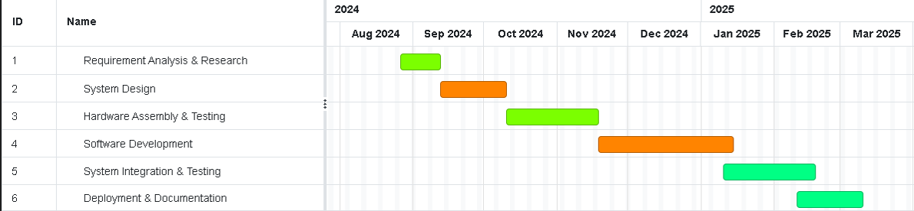
1:Requirement Analysis & Research
START DATE: 26Aug 2024
FINISH DATE: 12Sep 2024
DURATION:14 days
2: System Design
START DATE: 12Sep 2024
FINISH DATE: 10Oct 2024
DURATION:21 days
3:Hardware Assembly and Testing
START DATE: 10Oct 2024
FINISH DATE:18 Nov 2024
DURATION:28 days
4: Software Development
START DATE: 18 Nov 2024
FINISH DATE:14 Jan2025
DURATION: 42 days
5: System Integration and Testing
START DATE: 14 Jan2025
FINISH DATE:20Feb2025
DURATION:28 days
6: Deployment and Documentation
START DATE: 20Feb2025
FINISH DATE: 20Mar 2025
DURATION:21 days

7.CONCLUSION:
In conclusion, the IoT-based Air Quality Index (AQI) Meter is a cost-effective solution for real-time monitoring of air quality. It collects, analyzes, and displays data, providing insights for proactive pollution mitigation and public health protection. The system integrates sensors, cloud connectivity, and data visualization tools, ensuring accurate readings and informed decision-making. This project could significantly contribute to environmental monitoring and improve quality of life by addressing air pollution challenges.

8.REFERENCES:
1:Dineshkumar, T., V. Suresh Babu, Pachaivannan Partheeban, and R. Puviarasi. "Air Quality Monitoring System Based on IoT." *Journal of Physics: Conference Series* 1964, no. 6 (2021): 062081. https://doi.org/10.1088/1742-6596/1964/6/062081.
2: Hemalatha, M., R. Arunprasath, J. Shalini Priya, A. M. Shivashankari, K. Rajkumar, and R. Jeyashri. "An IoT Enabled Air Pollution Meter with Digital Dashboard on Smartphone." In 2023 Intelligent Computing and Control for Engineering and Business Systems (ICCEBS), IEEE, 2023. https://doi.org/10.1109/ICCEBS58601.2023.10448896.
3: Yusof, Khairul Huda, M. Abdulrazaq, Fadhilah Aman, M. N. Mohammed, Amirul Asyraf, Ahmad Sukri Ahmad, and Mohamad Syahrul Zahwan Mohd Zabidi. "Design and Development of Real Time Indoor and Outdoor Air Quality Monitoring System Based on IoT Technology." In 2022 IEEE 18th International Colloquium on Signal Processing & Applications (CSPA 2022), Selangor, Malaysia, May 12, 2022. IEEE. https://doi.org/10.1109/CSPA55076.2022.9781937.
4: Yusof, K. H., Abdulrazaq, M., Aman, F., Mohammed, M. N., Asyraf, A., Sukri, A., Zabidi, M. S. M., & Alayham, A. R. (2022). Design and Development of Real Time Indoor and Outdoor Air Quality Monitoring System Based on IoT Technology. 2022 IEEE 18th International Colloquium on Signal Processing & Applications (CSPA 2022), 12 May 2022, Selangor, Malaysia.
https://ieeexplore.ieee.org/document/9781937
5: Sharmila, A. R., J. J. Edwin, T. Sivakumaran, A. P. Prabhu, and R. T. Rajesh. 2022. "Design and Development of Real Time Indoor and Outdoor Air Quality Monitoring System Based on IoT Technology." In *Proceedings of the 2022 IEEE 18th International Colloquium on Signal Processing & Applications (CSPA 2022)*, 187-192. Batu Ferringhi, Malaysia: IEEE. https://doi.org/10.1109/CSPA53698.2022.9779578.
6: IoT Based Air Quality Monitoring System Using Arduino Shazia Afroze 1 , Md. Istiak Hossain Paran 2 , Rakibul Hasan Roki 3 1Assistant Professor, Dept. of Electrical & Electronic Engineering, Stamford University Bangladesh (SUB) 2,3Student, Dept. of Electrical & Electronic Engineering, Stamford University Bangladesh (SUB). https://www.ijfmr.com/papers/2023/2/2260.pdf
7: IoT Based: Air Quality Index and Traffic Volume Correlation Omar Alruwaili; Ivica Kostanic; Ali Al-Sabbagh; Hamad Almohamedh. https://ieeexplore.ieee.org/document/9298176/references#references
8: IoT-based_air_quality_monitoring_systems_for_smart Danny Múnera Diana P. Tobon V.
Johnny Aguirre Natalia Gaviria. https://www.researchgate.net/publication/350823548_IoT-based_air_quality_monitoring_systems_for_smart_cities_A_systematic_mapping_study
9: IoT-based_AQI_Estimation_using_Image_Processing_and_Learning_Methods Nitin Nilesh; Ishan Patwardhan; Jayati Narang; Sachin Chaudhari. https://ieeexplore.ieee.org/document/10152272
10: IoT Based Air Quality Index (AQI) Monitoring with ESP8266 & Air Quality Sensor || Pollution in PPM. https://www.youtube.com/watch?v=Ub1ciur95Nk
11: How to Monitor Air Quality Using ESP32 | Air Quality Monitoring System | ESP32 | Blynk IOT Projects. https://www.youtube.com/watch?v=mvdpAeBVIEg
12: ESP32/ESP8266 https://www.espressif.com/en/products/socs/esp8266/esp32
13:Arduino https://www.arduino.cc
14:MQ SERIES GAS SENSOR(MQ-135 OR MQ-5) https://quartzcomponents.com/products/mq-135-air-quality-gas-sensor-module?srsltid=AfmBOop5mXIPlIYk9hktUux7liYaVdUBpKL6kbz0WWrxTpIWOT2KrvzP https://quartzcomponents.com/products/mq-5-gas-sensor?pr_prod_strat=e5_desc&pr_rec_id=d76f6fda8&pr_rec_pid=4491697127559&pr_ref_pid=4491637817479&pr_seq=uniform
15:PM2.5 AND PM10 SENSOR https://www.aeroqual.com/sensors/particulate-matter-sensor-pm10_pm2-5
16:BATTERY PACK https://digilog.pk/products/3-7v-2400ma-li-ion-battery-pack-40mm-x-30mm-x-20mm?_pos=13&_sid=2e7bcb6e9&_ss=r
17:WiFi/BLUETOOTH MODULES https://www.electronicwings.com/nodemcu/hc-05-bluetooth-module-interfacing-with-nodemcu
18:ANDROID STUDIO https://developer.android.com/studio?_gl=1*ae3zhz*_up*MQ..&gclid=Cj0KCQjw28W2BhC7ARIsAPerrcIja-b-lMf3oSKZuIHQbv0cpPHynzM9mqTFolAh2u5Jwl_PLXT8ekQaAjBeEALw_wcB&gclsrc=aw.ds
19:FIREBASE https://firebase.google.com/?gad_source=1&gclid=Cj0KCQjw28W2BhC7ARIsAPerrcI94T6cSy7drbjU0zQU_a4MeNrUMZAfQ8a8eirac0VXoSY6-GZI_fwaAqw-EALw_wcB&gclsrc=aw.ds
20:BLYNK APP https://blynk.io/no-code-iot-mobile-apps
21:MATLAB https://www.mathworks.com/products/matlab.html
22:PYTHON https://www.python.org https://www.anaconda.com
23:ARDUNIO IDE https://www.arduino.cc/en/software/
24:ESPRESSIF IDF https://idf.espressif.com
25:THINGS SPEAK https://thingspeak.com
26:MQTT PROTOCOLS https://mqtt.org
27:AWS IOT https://aws.amazon.com/iot/
28:ADAFRUIT IO https://io.adafruit.com
29:GITHUB https://github.com
30:AUTHENTICATION MECHANSIMS https://www.techtarget.com/iotagenda/tip/IoT-device-authentication-methods-that-increase-security
31:GAFRANA https://grafana.com
32:EXCEL https://www.microsoft.com/en-us/microsoft-365/excel
33:HTTP/HTTPS https://aws.amazon.com/compare/the-difference-between-https-and-http/#:~:text=In%20short%2C%20HTTP%20protocol%20is,encrypted%20connection%20before%20transferring%20data.
34:SENSOR AND WiFi LIBRARIES https://www.arduino.cc/reference/en/libraries/wifi/
35:GANTT CHART https://www.onlinegantt.com/#/gantt

9.COLLABORATORS:

RISETECH OF NUST EME COLLEGE

BIOMISA OF NUST EME COLLEGE

DR USMAN AKARM

DR SAJID GUL KHAWAJA

